Lab 2: New ES6 Features
In this lab, you'll use some new ES6 features. You'll code classes the ES6 way and use arrow functions/expressions among other things.
Part 1: Using ES6 Classes
Here you’ll create a set of classes using ES6 constructs. You’ll create three classes: BankAccount (parent) and two children (Savings and Checking).
After you write code you can check its syntax by using Esprima located at http://esprima.org/demo/validate.html (Just one of countless JS syntax checkers out there!) Nothing fancy; just gets the job done. Just copy/paste code into its window.
Here’s what it looks like:
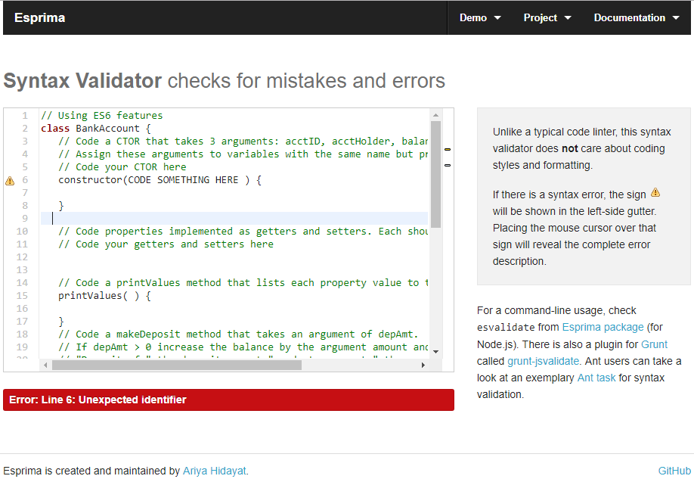
The folder starterforclassesBackup is available in case you totally hose your starter files :(
Step 1: Create a BankAccount class
The file starterforclasses/bankaccountES6.js has copious instructions for creating your bankaccount class. Short story – code a CTOR, properties (getters/setters), printValues, deposit and withdrawal methods.
This class will serve as the parent class for the two classes (savings, checking) that you will code next. Put your code in the classes directory.
Step 2: Create the CheckingAccount class
Again, start with starterforclasses/checkingES6.js for instructions. This class is a child of the aforecoded (I made up a word!) BankAccount class. The checking account class has a property, odProtection (Overdraft Protection) in addition to the inherited properties from its parent. The odProtection property is a BOOLEAN that states whether or not the account has overdraft protection.
Include the additional property in your CTOR and assign AFTER calling the parent class CTOR; override the printValues method to include the value of the additional property odProtection and overide the makeWithdrawal method to check the odProtection flag.
Look in the starter file for more detailed instructions. Put your code in the classes directory
Step 3: Create the SavingsAccount class
Last step is to create a child class called SavingsAccount that will inherit ALL the properties of BankAccount and include an additional property called interest. This property is a double that we’ll use in a totally nonsense way to adjust the balance of a savings account.
Pretty much the same spiel as given for the CheckingAccount class; code the CTOR to accept the parent properties and the additional interest property, override the printValues method to list the value of the parent and new property values to the log and override the deposit method to use our interest rate property. Put your code in the classes directory

Step 4: Doing stuff with these classes
Remember to use the developer tools since your output is going to the console!!!
As you likely figured, you have a starter file, useES6FeaturesStarter.html. Take a look while you read what follows.
The function createBunchaAccounts returns an array of account objects. It’s argument is the number of accounts to create. Use a new ES6 feature to default tha arguments value to 50.
Don’t code var for all your JS variables! Think of some more appropriate ES6 keyword that may describe the ‘kind’ of variable better.
List out the account IDs with a forEach function call. The forEach function takes a function argument that describes what to do with each element of the array. You can code the function externally or code the function body within the call to forEach. The function listAcctID is already coded for you; you can use this as an argument to forEach.
Next, use filter to count the number of savings accounts. The accountIDs start with the letter that describes the account. (‘S’ for savings, etc.)
Use reduce to compute the sum of ALL accounts, then divide by the number of accounts to compute the average. Print the average to the log.
The next two are ***OPTIONAL***
Filter out the savings accounts with balance > 5,000$. Change the balance by using the map function to apply the interest rate (newbalance = oldbalance * ( 1 + interestRate ) ). Finally, list the acctID and the (new) balance with a forEach function.
Lastly, use reduce to count the number of each account type.
The starter has lots of comments. Remember to use the syntax checker from time to time!
Step 5: Using ES6 Arrow functions
Take the program you just wrote and change the calls to reduce, forEach, map, filter to use arrow functions.
Refer to the Ohs for syntax examples.

